**Q9. Try Inter VLAN routing with Router.**

**Network setup:**

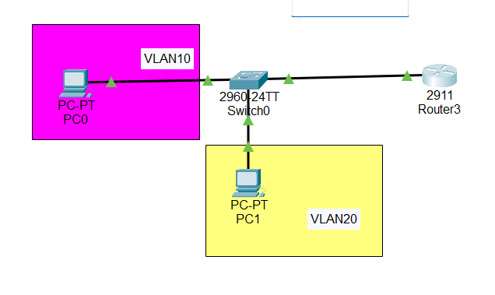

**Configuring switch:**

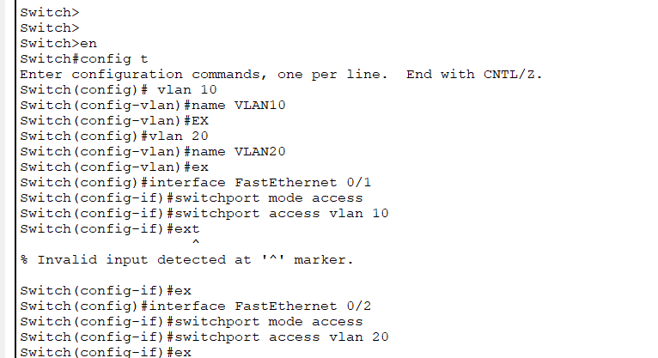

**Trunk port connection to router:**

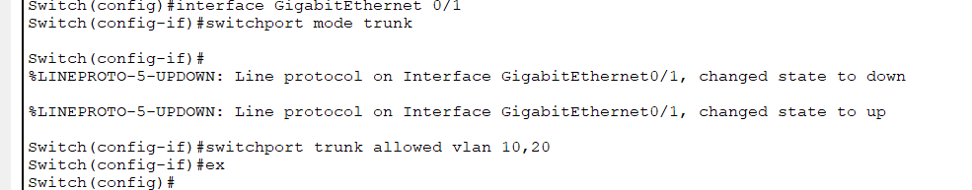

**VLAN Table of switch:**

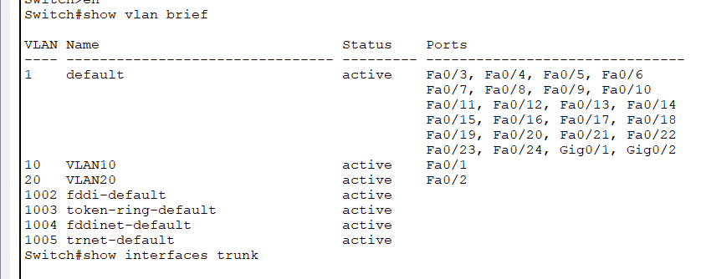

**Configuring router:**

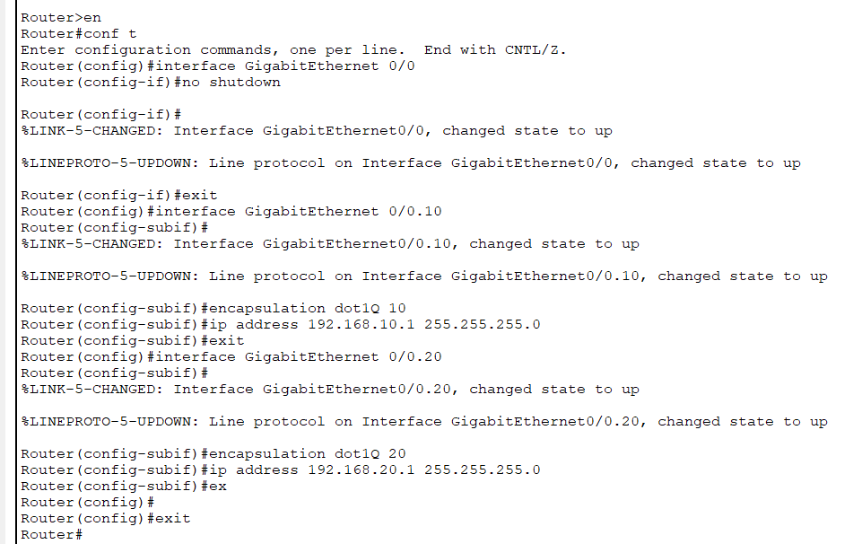

**Verifying connectivity(PC0 -> PC1)**

